Phosphate Assay Protocol

- Prepare a solution of 1 mM KH₂PO₄ and aliquot into volumes of 0, 25, 50, 75, 100, 150, 200 and 400 ul. Calculate how many ug of phosphate are in each sample. (If running phosphate assay standard curve – or else add in lipids resuspended in buffer instead)
- Aliquot samples of the extracted lipids into 13x100mm borosilicate Pyrex collection tubes. Deposit the sample as close to the bottom of the tube as possible.
- Dry the samples under N₂ gas – see below. (Evaporating at 37°C takes too long)
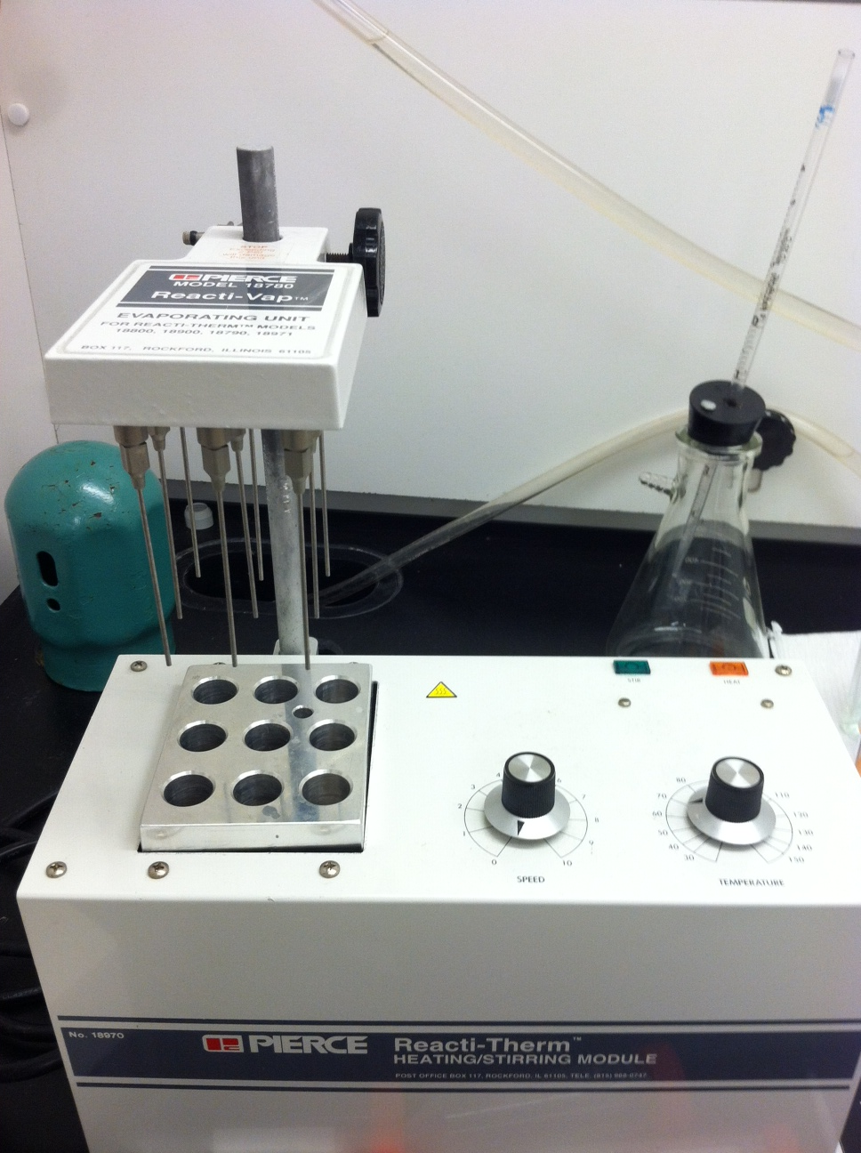

- Add 100 ul of concentrated sulfuric acid (H₂SO₄) to each sample and mix by vortexing.
- Incubate tubes at 155 °C in the heating block for 10 minutes. Switch out the 9 well heat block with the 13 well block.
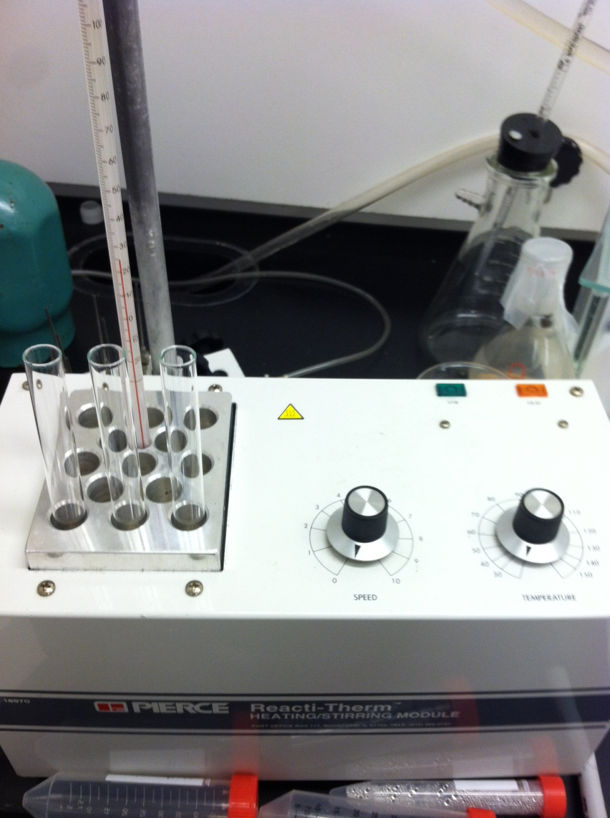
- Allow tubes to cool, then add 50 ul of 6% hydrogen peroxide (H₂O₂) and vortex.
- Incubate tubes at 155 °C in the heating block for 40 minutes.
- Allow tubes to cool, then add 2 ml of distilled H₂O and vortex.
- Add 800 ul “color reagent” to each tube
- Heat samples in a boiling water bath for 7 min, or until highest standard turns dark blue.
- Measure absorbance at 797 nm.
- Make a standard curve of A₇₉₇ vs. Phosphate Content

To make 6% hydrogen peroxide:
- We have 35% H₂O₂
- 35/6 = 5.83 fold dilution
- 1:4.83 = H₂O₂: H₂O
- To make 100 ml of 6% H₂O₂ combine:
  - 17.2 ml of 35% H₂O₂
  - 82.8 ml of H₂O
- Store in a foil covered bottle in the refrigerator

To make 10.1 mM ammonium molybdate:
To make 100 ml of a 10.1 mM solution:
- Weigh out 1.25 g ammonium molybdate powder
- Add 100 ml of H₂O
- Store at room temperature in a foil-covered bottle

To make 0.28 M ascorbic acid:
To make 100 ml of a 0.28 M solution:
- Weigh out 4.93 g ascorbic acid powder
- Add 100 ml of H₂O
- Store at room temp in a foil-covered bottle for short periods of time (1-2 days max)

To make color reagent:

Combine equal volumes of 10.1 mM ammonium molybdate and 0.28 M ascorbic acid immediately prior to use. Ascorbic acid must be made fresh or at most one day in advance. If old ascorbic acid has a yellowish tinge, do not use.

