Protocol for Growing and Purifying E. Coli Lipids
Day 0:
- Prepare an LB-agar + amp plate
- Take some kdo₂-Lipid A E. coli from the glycerol stock and streak on plate (in Genualdi’s Glycerol Stock box in the -80ºC freezer in the tubes labeled “E. coli hep-knockout kdo₂-lipid A”)
- Place in 37ºC incubator overnight
Day 1:
- At the beginning of the day, prepare a 3 ml liquid culture of cells in 2XYT supplemented with 3 ul of 50 mg/ml kanamycin for a final concentration of 50 ug/ml.
- Incubate the culture at 37°C in the shaker for ~3-4 hours.
- When the cells have reached mid log phase (culture becomes cloudy) transfer 125 ul of the culture to a 250 ml Erlenmeyer flask containing 25 ml 2XYT supplemented with 25 ul of 50 mg/ml kanamycin for a final concentration of 50 ug/ml.
- Incubate the culture at 37°C in the shaker overnight.

Day 2:
- Supplement 500 ml modified LB (modified LB is the standard LB with twice the NaCl – the LB mixture we have is the modified version) with 500 ul of 50 mg/ml kanamycin for a final concentration of 50 ug/ml, and inoculate with 2.5 ml of the overnight culture.
- Grow cells to early stationary phase in our baffled flasks. (~400-450 minutes)
- Recover cells by centrifugation in JA-10 rotor at 5,000 rpm for 15 min @ 4°C.
- Tare a 15 ml conical tube on the scale.
- Transfer the cell pellet to the conical tube, record the weight of the cell pellets and store at -20°C overnight.

Day 3:
- Resuspend cell pellet in 16ml PBS. Use two washes of 8 ml to ensure all cell paste is removed from conical tube. Transfer to solvent resistant centrifuge tube.
- Add 20 ml chloroform and 40 ml methanol to the centrifuge tube. Use the glass and bulb pipettes when working with organic solvents.
- Stir using a Teflon-coated stir bar in the hood for 1 hour. Cover the lid of the tube so that the solution does not evaporate.
- Remove stir bar and centrifuge in the JA-14 rotor at 2,450 rpm (~921 x g) for 30 minutes at room temperature.
- Transfer supernatant to a clean solvent resistant bottle. If there is no second bottle, transfer the supernatant to a glass container, and then clean the bottle.
- Add 20 ml of 0.1 N HCl and 20 ml chloroform to the supernatant and mix well.
- Centrifuge in the JA-14 rotor at 2,450 rpm for 10 minutes at room temperature.
- Remove the LOWER organic phase using a glass pipette and transfer to a 200 ml round bottom flask.
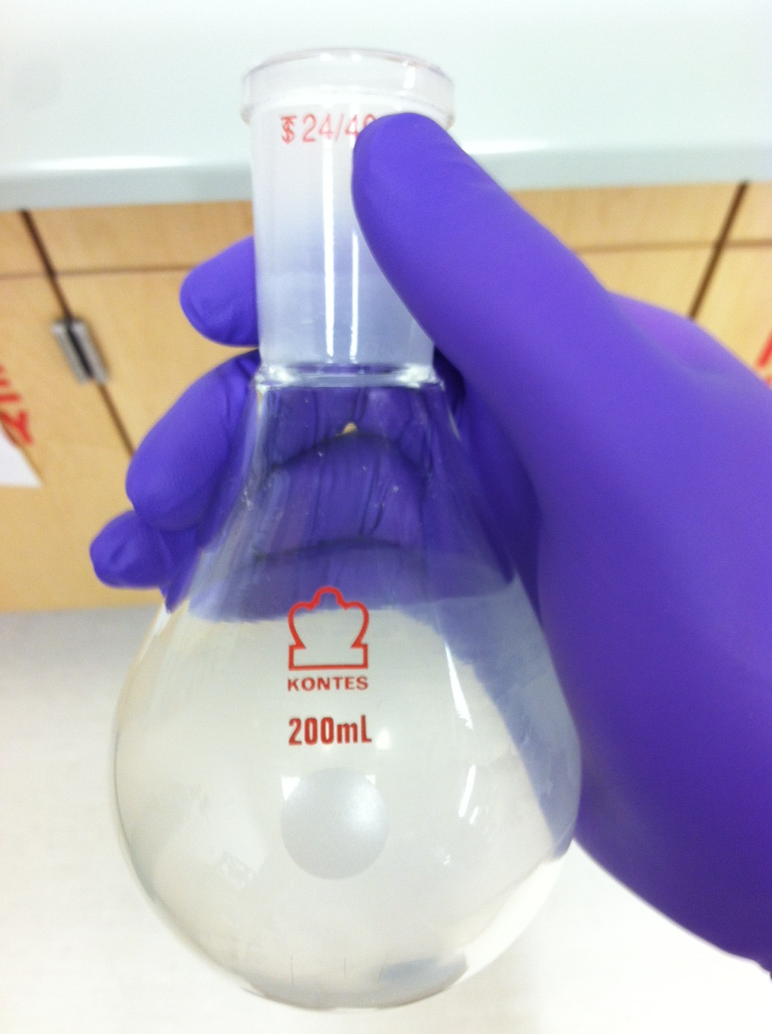
- Add 40 ml chloroform to the centrifuge tube and mix well.
- Repeat steps 7-8
- Add 1 drop of pyridine for every 10 ml of organic phase to neutralize the mixture. Make sure you do this in the hood! Pyridine fumes are not pleasant.
- Remove the solvent from the organic layer using the rotary evaporator (rotovap). Do not fill the round bottom flask more than half the volume. If necessary, rotovap ~100 ml at a time and add more to the flask once solvent is evaporated.
Rotovap Procedure:
  - Make sure the condenser, collection flask, round bottom flask containing the organic solution, and all tubes are securely attached to the rotovap.
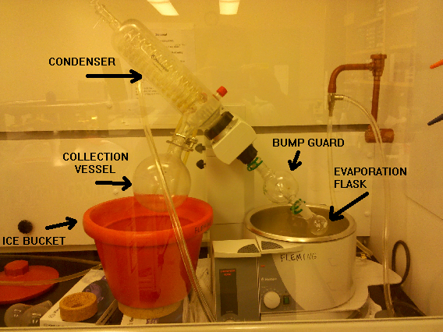
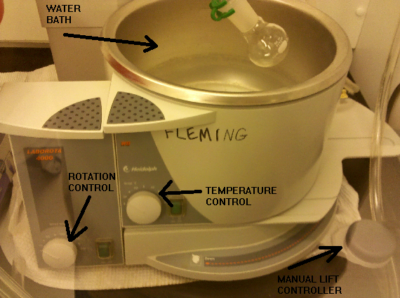
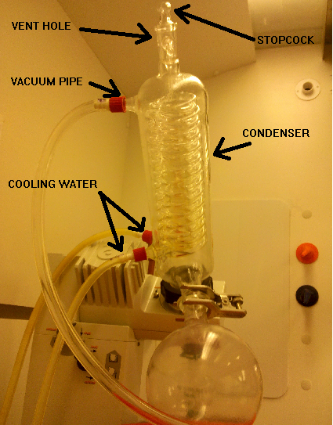
  - Turn on the water to the condenser; a gentle stream is sufficient.
  - Open the stopcock at the top of the condenser.
  - Turn on the vacuum water supply; the water should be on all the way. Be careful and make sure that water does not back up into the tubing. If the flow changes and this begins to happen, vent using the stopper at the top of the condenser.
  - Begin rotating the round bottom flask.
  - Using your finger, cover the vent at the top of the condenser to begin pulling a vacuum. If the sample starts to boil, remove your finger from the vent to release the pressure. Once boiling has stopped, cover the vent again. Repeat this process until the sample “calms down”.
  - Once the sample is stable, close the stopcock at the top of the condenser, but always be ready to open it if pressure needs to be released.
  - Lower the round bottom flask into the water bath so that just the lower surface is submerged. If the solution starts to boil vigorously, release the vacuum.
  - Once the solution is “stable” in the water bath, allow the solution to evaporate from the round bottom flask. If evaporation is going too slowly, the temperature of the water bath can be increased, or the collection flask can be cooled further.
  - Once evaporation is complete, raise the flask out of the water bath, then stop the rotation.
  - Release the vacuum stopcock. Once the vacuum is released, carefully remove the round bottom flask.
  - Turn off the aspirator and condenser water streams.
  - Dispose of waste solvent from the collection flask.
- Resuspend lipids in 5 ml of 4:1 chloroform:methanol (v:v)
- Sonicate in round bottom flask for 30 seconds and transfer solution to a glass tube. Make sure to sonicate all surfaces of the flask that could have lipid dried on.
- Repeat 13-14, combining the two 5 ml samples
- Aliquot 10 x 1 ml samples into lipid vials, and dry under N₂ gas
- Dry overnight under vacuum
- Store under N₂ gas in the -20°C freezer

