Spectral Line Pairing for Heterodyne OCDMA

Yi Yang, A. Brinton Cooper III, and Jacob B. Khurgin

Abstract – A novel OCDMA scheme uses spectral line pairing to generate signals suitable for heterodyne decoding. Both signal and local reference are transmitted in one optical fiber and a simple balanced receiver performs sourceless heterodyne detection. A prof of principle 16 user fully loaded system phase encoded with Hadamard codes are simulated. Effects of Dispersion, signal and reference delay at OLT is also studied.
Index Terms— Optical fiber communication, OCDMA, SPE, Heterodyne detection

Introduction
Optical code division multiple access (OCDMA) over the passive optical network (PON) is emerging as a key access network technology [1]. For most common OCDMA system, a short optical pulse is encoded with optical codes and it share the same transmission media with other users (eg. spectrum or time). At the receiver, a matched filter performs decodes the targeted user through autocorrelation, while the crosscorrelation of unintended users signal become noise like low level output [ref]. In such system, a fast detector is required and a fully loaded system decreases the signal to noise ratio at the detector. We have previously demonstrated that coherent spectrally phase encoded (SPE) OCDMA with a phase and polarization diversity (PPD) combiner eliminates speckle and most multiple access interference (MAI) in a homodyne conﬁguration without the need for fast detectors or phase locking [2]. However, the PPD receiver is rather complex and the system required two fibers, one to carry the signals, and one for the reference light [ref]. A spectral amplitude coding OCDMA system has been proposed to use a simple balanced detector for heterodyne detection; however, the network required a multi wave length light source at the ONU [ref].
This work proposes, and through simulation, , demonstrates a novel heterodyne scheme that pairs an encoded optical comb with the unencoded reference comb that is spectrally offset by the bit rate, resulting in a much simpler sourceless receiver with comparable dispersion and signal and reference delay tolerance.

SYSTEM DESCRIPTION
This work was supported by the US National Science Foundation under Grant ECCS-0925470 and was funded under the American Recovery and Reinvestment Act of 2009 (ARRA).
The authors are with Department of Electrical and Computer Engineering, The Johns Hopkins University, Baltimore, MD 21218 USA.

As in [2], all optical signals are sourced from a single mode-locked laser (MLL). Sets of spectral lines (Fig.1) for SPE (red dashed lines) and for the unencoded reference comb (green solid lines) are obtained by ﬁltering the MLL pulse with an arrayed waveguide grating (AWG). The spacing of each signal comb is 320 GHz, and the reference comb is offset from the data-carrying comb by the bit rate of 40 GHz. Sixteen spectral lines are encoded with up to 16 distinct, orthogonal Hadamard codes (Fig 2c). The reference comb (Fig. 2b) is not encoded. All 16 users are modulated with pseudo random data through OOK. The signal and reference light are multiplexed at a star coupler, and send to the ONU via one ﬁber to all users (Fig. 2d). At the receiver, the signal is split into two paths. One is sent to the coupler, and another one to an AWG. The reference comb is captured and encoded with the desired user’s sequence in the SPE AWG, while the signals are being filtered out. The encoded reference is sent to the coupler, as shown at Fig. 2e with the balanced mixer following. Both signals are applied to the balanced detector, which effectively multiplies the two signals, producing baseband data at 40 GHz. A 79 GHz band pass ﬁlter centered at the 40 GHz intermediate frequency ﬁlters out higher frequency beat signals (Fig. 2f). Beat noise and direct detection components can be removed by a band pass filter acting as an intermediate frequency filter [ref].
Hadamard sequences are used for SPE because true orthogonally of the transmitted waveforms is easily achieved. The complex conjugates of the phase encoding sequences permit the decoder to produce a true autocorrelation (with positive and negative terms) having a sharp peak and to achieve near-zero pairwise cross correlations. Phase locking and fast nonlinear threshold detectors are not needed, and the balanced detectors provide tolerance to phase and polarization fluctuations [3].

Fig. 1. Frequency comb for signal and reference

SIMULATION AND RESULTS
Fig. 2 shows the system model and simulated waveforms for 16 users at 40 GHz. The 1550 nm mode-locked laser (MLL) pulse width is 500 fs (fig 2a), and the main lobe of the optical comb is ﬂattened (perhaps by adapting quantum dot

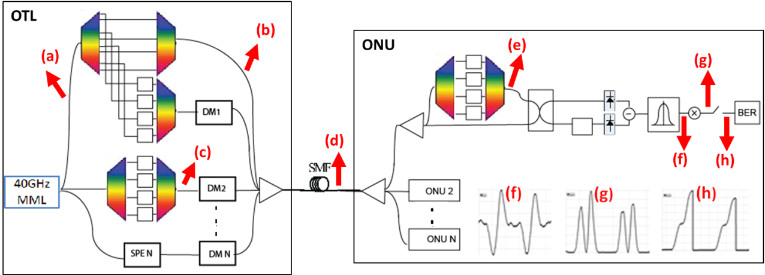
A
Fig. 2. System setup and output

gain materials into the MLL [3]) to ensure full signal orthogonality. SPE for 16 users is performed as in [2];
The output of the BP is then squared (Fig. 2g) and a 40GHz integrator follows. The integrator performances integrate and dump to fully retrieve the transmitted signal data (Fig. 2h). The integrator’s value is sampled before the dump function and is sent to BER calculator for system performance evaluation.
Fig. 3 compares the BER of the heterodyne detection OCDMA with that of the SPOT homodyne scheme [2]. Previously, we have shown: for SPOT homodyne detection OCDMA scheme, the BER decreases exponentially as SNR increases since the codes are orthogonal. The heterodyne OCDMA scheme encoded with Hadamard sequence possess the same characteristics, and error free (BER < 10⁻⁹) transmission has been achieved when the system is fully loaded. The nearly 2 dB improvement is the result of using two photodiodes instead of eight [3].
One of the major causes of MAI comes from fiber dispersion. As previously reported [4] for homodyne reception with on-off keying (OOK), encoded signals with energy concentrated at the edges of the pulse interval (e.g., H9) are susceptible to 1 → 0 bit errors due to dispersive channel effects smearing energy to the 0 interval. However, the same sequence, when used in the proposed heterodyne system with the same load and SNR, can withstand twice the dispersion for the same BER (Fig. 4). Conversely, a waveform with energy concentrated away from the boundaries of the interval (e.g., H10) is highly dispersion resistant in the homodyne system (Fig. 5) but relatively far less so in the proposed heterodyne system (Fig. 4). Therefore, it appears that the proposed scheme is resistant to the “spilling” of energy into the adjacent pulse interval, but is susceptible to pulse broadening by dispersion
induced compromise of the phase coherence among the lines of the encoded pulse.
B

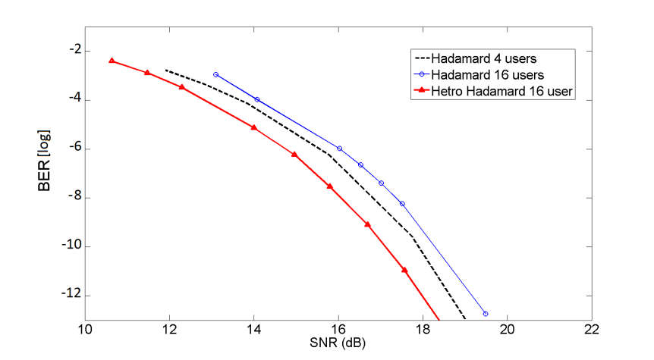
Log₁₀BER
Fig. 3. BER vs. SNR for Homodyne and Heterodyne detection

In order to separate and spectrally encode reference and signal comb, line by line pulse shaping technique has been demonstrated. Complex waveforms can be generated through independently manipulate the spectral amplitude and phase of individual lines from a MML [8]. The Minimum resolution for such system is 10GHz between spectral lines. However, the added path line length to either signal comb or reference comb cause asynchronous, which leads to higher MIA. Asynchronous study has been done on both OTL and ONU in this simulation to measure how the raise of MIA would affect system performance. In the first study, a delay is introduced at the OTL side, at point A in Fig. 2, at which the encoded signal comb is multiplexed with other signals and reference. Fig.6 shows the encoded signal and reference asynchronous bit error rate for different system load. We can see that system can tolerate more asynchronous when the load it’s small. However, as the signal and reference asynchronous increases to 0.16ps, the system BER tends to merge in spite of the capacity.
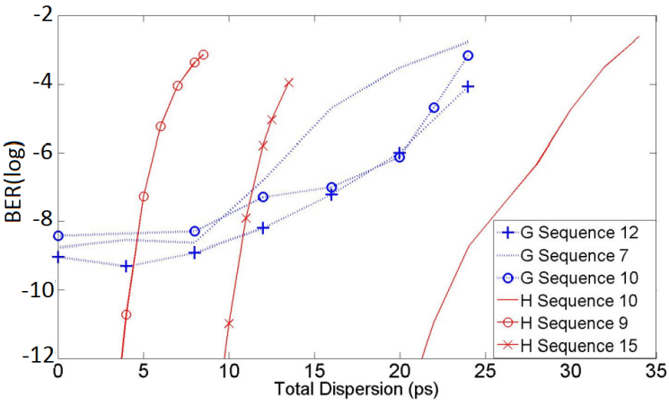 Fig. 4. Performance vs total dispersion
Fig. 5. Homodyne performance vs total dispersion (from[5])

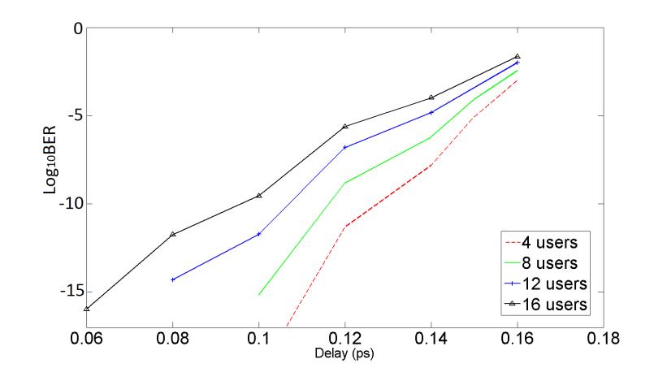
Fig. 6 BER vs. Delay

Asynchronous between the signals and the encoded reference comb at the ONU is also studied. A delay is introduced at point B in Fig. 2, before the encoded reference comb is sent to the coupler. Fig.7 shows the encoded signal and reference asynchronous bit error rate for different system load. We can see that system can tolerate more asynchronous when the load is small, and this tolerance decrease as system capacity increases. The difference between Fig. 6 and Fig. 7 is that in Fig. 6, MIA comes from the targeted encoded signal, while in Fig. 7, the cause of MIA comes from all loaded users.

CONCLUSION
A new heterodyne architecture with a simple balanced receiver for SPE-based OCDMA has been proposed. Its power efﬁciency compares favorably with the SPOT homodyne design and its resistance to total dispersion is competitive with that of SPOT. The asynchronous cause has been indentified and studied. Our further study will be construct a proof of principle OCDMA system based on this study.

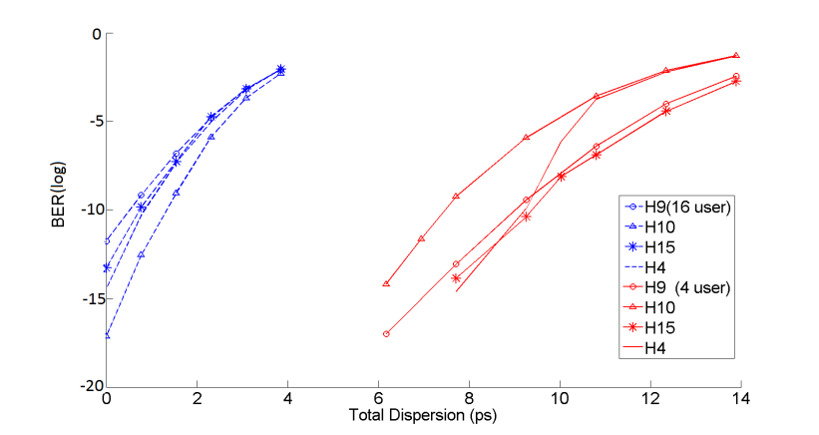

Log₁₀BER

Log₁₀BER

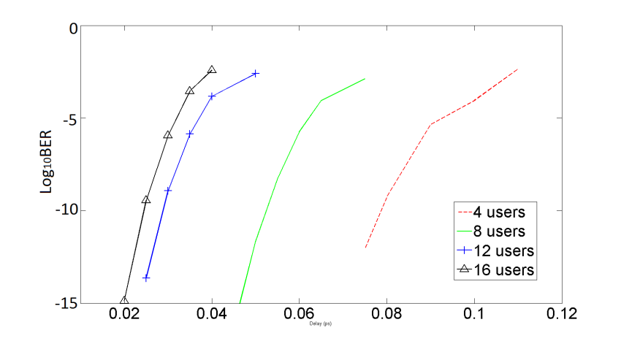
Fig. 7 BER vsd. Delay

REFERENCES
- A. B. Cooper III, J. B. Khurgin, and J. Kang, “Phase and polarization diversity for OCDMA,” in Conference on Lasers and Electro Optics (CLEO) ’06, Optical Soc. of Amer., 2006.
- A. B. Cooper III, J. B. Khurgin, S. Xu, and J. U. Kang, “Phase and polarization diversity for minimum MAI in OCDMA networks,” IEEE J. Select. Topics in Quantum El., vol. 13, pp. 1386–1395, Sept. 2007.
- J.S.Parker, P. Binetti, A. Bhardwaj, R. Guzzon, E. J. Norberg, Y. Hung, L.A. Coldren. “Comparison of Comb-line Generation from InGaAsP/InP Integrated Ring Mode-locked Lasers,” (CLEO) ’11, Optical Soc. of Amer., 2011.
- Y. Yang, A. B. Cooper III, J. B. Khurgin, and J. Kang, “Sequences for Impairment Mitigation in Coherent SPE-OCDMA,” 2011 Signal Processing in Photonics Communication (SPPCOM) Topic Meeting, OSA Advanced Photonics Conference, June 15, 2011
- Yoshino, M.; Kaneko, S.; Taniguchi, T.; Miki, N.; Kumozaki, K.; Imai, T.; Yoshimoto, N.; Tsubokawa, M.; , "Beat Noise Mitigation of Spectral Amplitude Coding OCDMA Using Heterodyne Detection," Lightwave Technology, Journal of , vol.26, no.8, pp.962-970, April15, 2008
doi: 10.1109/JLT.2008.917369
- N. Wada and K. Kitayama, “Error-free 10 Gbit/s transmission of coherent optical code division multiplexing using all-optical encoder andbalanced detection with local code,” in Proc.OFC ’98,Mar. 1998, FE7.
- Zhensen Gao, Xu Wang , Nobuyuki Kataoka, and Naoya Wada, "Rapid Reconfigurable OCDMA System Using Single-Phase Modulator for Time-Domain Spectral Phase Encoding/Decoding and DPSK Data Modulation," J. Lightwave Technol. 29, 348-354 (2011)
- S. Etemad , Shahab Etemad , P. Toliver , J. Young , R. Menendez , Jeff Young , T. Banwell , S. Galli , C. Price , J. Jackel , Senior Member , P. Delfyett , Craig Price , T. Turpin, “Spectrally Efﬁcient Optical CDMA Using Coherent Phase-Frequency Coding,” IEEE Photonics Technology Letters, vol. 17, No.4, April 2005

