Protocol for Thin Layer Chromatography of E. coli Lipids

- Cut silica-covered TLC plate to desired length and bake at 50-60°C in the oven on the floor next to the centrifuge for at least 30 minutes

- In the hood, make the following developing solvent in a glass beaker (25:15:3.5:4; v:v)
  - 25 ml chloroform
  - 15 ml methanol
  - 3.5 ml acetic acid
  - 4 ml H₂O
- Line the TLC chamber with a large piece of filter paper (take the 18.5 cm one, cut in half, and line the chamber with both pieces
- Pour developing solvent into the TLC chamber. Make sure to wet the filter paper so it sticks to the sides of the chamber. Add enough solvent so the liquid level is ~0.5 cm. You can always add more solvent if necessary.
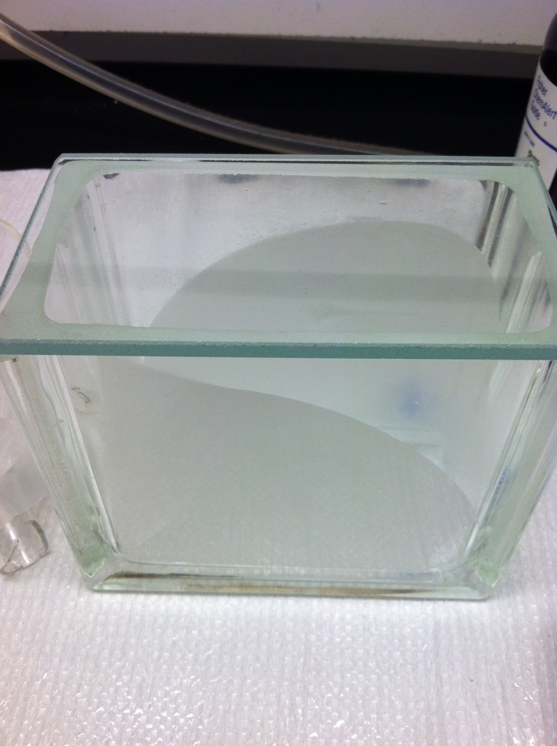
- Cover the developing chamber with its lid, and allow the system to equilibrate for ~2 hours in the hood.
- While the TLC chamber is equilibrating, rehydrate any samples/standards that you will be running using chloroform.
- Once the chamber is equilibrated, remove the TLC plate from the oven and lightly mark it using a pencil as shown below:

The distances shown are not absolute, just more of a general suggestion. The line at the bottom has to be high enough so that it is not below the developing solvent when placed in the TLC chamber. The line at the top is so you have a reference point at which to remove the plate from the chamber, and also makes it easier to measure the R_{f} value in the end. The small dashes on the bottom line indicate where to spot your samples.

- Using 2 ul microcaps, spot desired samples/references onto the appropriate dashes on the plate.
- Allow spots to dry for ~10 minutes
- Place TLC plate in the developing chamber, leaning it up against one of the long walls. Make sure that the line containing the samples does not get submerged in the developing solvent.
- Close the lid of the TLC chamber and allow plate to develop.
- Monitor the rising solvent line, and remove the plate once it reaches the line at the top of the plate.
- After removing the plate, allow it to dry in the hood.
- Once the plate is dry, place the plate in a spraying chamber (just a cardboard box lined with tin foil).
- Spray the plate with a solution of 1:9 sulfuric acid:ethanol (v:v). Try to get an even spray with a fair amount sprayed on, but not so much that its dripping wet.
- Place the plate on a hot plate with the temperature turned up about 75% of the way. No specific temperature is necessary, as we do not have the capability to measure temperatures over 150°C.
- As the plate begins to char, watch for dark brown/black spots to appear. Do not overheat the plate, as it will become unreadable if burned. Below is an example of what a completed plate should look like.
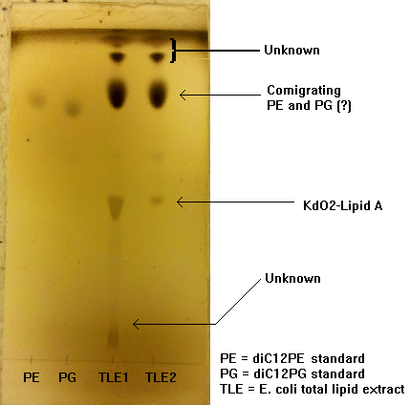

- Measure and record the R_{f} for each spot on the plate, and take a picture of the plate for future records.

