Concentrating Sample with Ultrafiltration Cell

We have a “Stirred Ultrafiltration Cell, Model 8010” from Millipore.
See product user guide for more details.

Assembly
- Place membrane in membrane holder, shiny side up.
  - Use for Skp: Regenerated cellulose, filter code: PLAC, diameter: 25mm, NMWL: 1,000, Cat. No. PLAC02510
- Place O-ring on top of membrane, pushing it down so entire O-ring is in contact with membrane (wear gloves).
- Place membrane holder onto base and screw cell body down onto it. O-ring will want to pucker up, so you need to hold it down with tweezers while sliding the cell body down on top, aligning the tabs on the sides of the holder with the slots in the base of the cell body.
- Filtrate exit tubing should already be attached to exit spout of membrane holder.
- Place stirrer into cell body, so that top of stirrer is resting on ridge inside cell body.
- Pour sample into the cell (10 mL at a time).
- Push cap assembly down onto cell body, using a twisting motion and orienting gas inlet port on cap opposite the filtrate exit port on the holder.
- Set pressure relief valve knob to horizontal (open) position.
- Slide cell into retaining stand, fitting the base into the hole in the stand. Place on stir plate.
- Turn pressure relief valve to vertical (closed) position.
- Attach gas pressure line to cap: Arrange hex nut, grab ring, spacer, and O-ring on hard red tubing (see Fig. 1). Insert tubing into cap assembly, slide hex nut over and tighten onto cap assembly.
- Red tubing should be connected to thicker pressure tubing (with cross-hatching) using special devices (see Fig 2).
- Place something on top of retaining stand (like a box of gloves) to hold it down because it can flop around when hooked up to gas tubing. Can also tape down tubing.
- Position filtrate exit tubing in conical tube next to stir plate.

Operation
- Turn on stir plate.
- Pressurize cell by turning on nitrogen gas. Cap should be pushed up against top of retaining stand. Adjust pressure to 70 psi (no higher!).
- Liquid should slowly drip from exit tubing, decreasing volume of sample in cell body.
  - Collect filtrate in order to check it for solute and make sure membrane was effective.
- If you have more sample to concentrate: unhook gas line, remove cap (see below), pour in more sample, then reassemble and run as before.

Disassembly
- When volume has reached desired level, turn off nitrogen gas.
- Vent the pressure inside the cell by slowly turning the pressure-relief valve knob to the horizontal position.
- To maximize recovery of retained substances, can stir for a few minutes after depressurization. This will resuspend the polarized layer at the membrane surface.
- Unscrew and remove gas line. Push cap down and slide cell out from retaining stand.
- Remove cap with a twisting motion and remove stirrer. Carefully pipette out sample.
- Disassemble everything and rinse thoroughly with water and allow to dry.

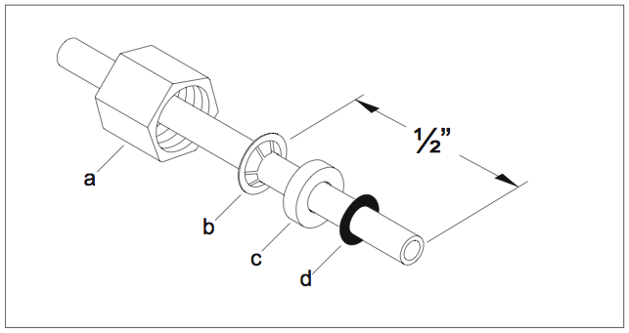
Fig. 1: Arrangement of pieces on red tubing at hook-up to cap assembly.
Fig. 2: Hook-up between red tubing and pressure tubing.

